Secure Shell (SSH)Theory (1 hour):Importance of SSH for secure communication.Configuring and securing SSH.Practical (1 hour):Configure SSH with key-based authentication.Task: Disable password login and document the configuration.
Tasks
1.Install the OpenSSH server package on your Linux system and verify that the sshd service is running by connecting to localhost using the ssh command.


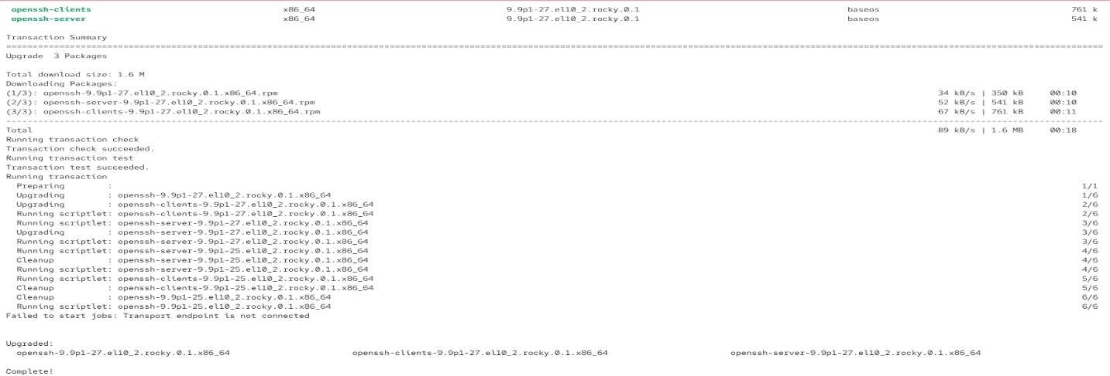

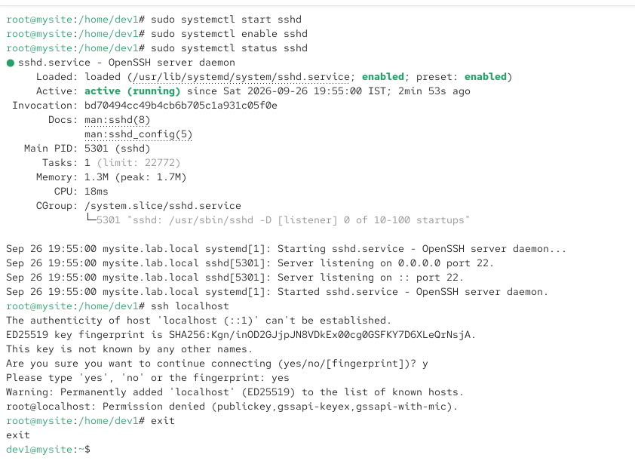
2.Generate a new SSH key pair using ssh-keygen, and add your public key to the ~/.ssh/authorized_keys file of your user account to enable key-based authentication.

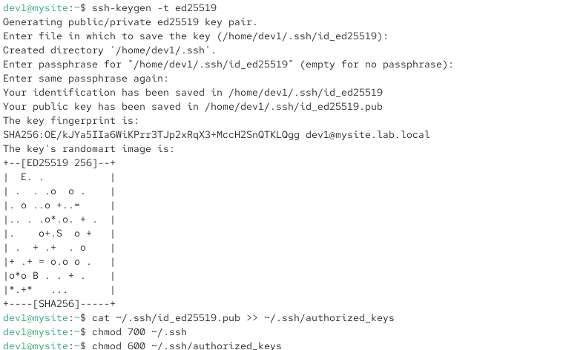
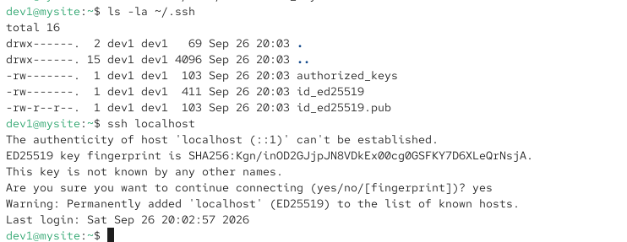
3.Edit the /etc/ssh/sshd_config file to disable password authentication by setting PasswordAuthentication no, then restart the sshd service and test that you can only log in using your SSH key.
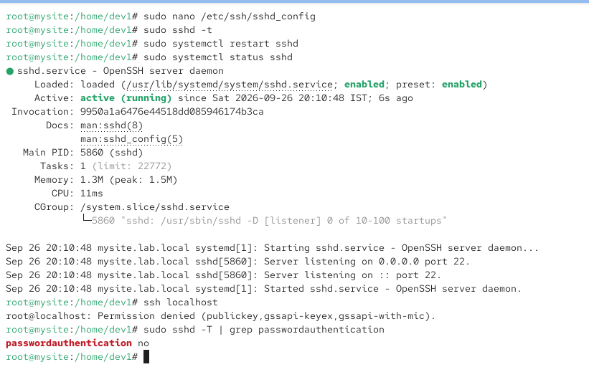

4.Document each step you took to configure SSH key-based authentication and disable password login, including the exact commands and configuration changes you made.Hint: Use screenshots or command outputs to support your documentation.
Step 1: Install and start SSH
sudo dnf install openssh-server -y
sudo systemctl enable --now sshd
Verify:
sudo systemctl status sshd
Expected:
Active: active (running)
Step 2: Generate an SSH key pair
On the client machine, run:
ssh-keygen -t ed25519
Press Enter for the default location. You can also enter a passphrase for better security.
Check the keys:
ls -l ~/.ssh/
You should see:
id_ed25519
id_ed25519.pub
Step 3: Copy the public key to the server
Replace 192.168.29.85 with your server IP if different:
ssh-copy-id root@192.168.29.85
Test key-based login:
ssh root@192.168.29.85
If it logs in without asking for the server account password, key authentication is working.
Step 4: Disable password authentication
On the server, edit:
sudo nano /etc/ssh/sshd_config
Find:
#PasswordAuthentication yes
Change/add:
PasswordAuthentication no
Also make sure public-key authentication is enabled:
PubkeyAuthentication yes
So the important settings are:
PubkeyAuthentication yes
PasswordAuthentication no
Save with Ctrl+O → Enter → Ctrl+X.
Step 5: Test the SSH configuration
Before restarting SSH:
sudo sshd -t
If there is no output, the configuration is valid.
Step 6: Restart SSH
sudo systemctl restart sshd
Check:
sudo systemctl status sshd
Step 7: Verify password login is disabled
From the client, try:
ssh -o PubkeyAuthentication=no -o PreferredAuthentications=password root@192.168.29.85
Password authentication should fail.
Then test normal key authentication:
ssh root@192.168.29.85
It should connect using your SSH key.
Screenshot evidence for your assignment
Take screenshots of:
- ssh-keygen -t ed25519
- ls -l ~/.ssh/
- Successful ssh root@192.168.29.85
- /etc/ssh/sshd_config showing:
- PubkeyAuthentication yes
PasswordAuthentication no
- sudo sshd -t
- sudo systemctl status sshd
- Failed password-only login and successful key login.

